HammerItOut

What is HammerItOut?
HammerItOut is an anti-bullying initiative launched by the British Orthopaedic Trainees Association (BOTA) in Jan 2017.
“We want to start a dialogue that leads to a positive change in culture within healthcare with orthopaedics leading the way.
What we hope to achieve:
- To create a positive workplace culture that is free from bullying, harassment and undermining behaviours
- To nurture an environment that empowers individuals to speak up if they experience or witness unacceptable behaviours.
- To promote and share examples of those who demonstrate exemplar behaviours in the workplace and use these to model further improvements in the wider NHS culture.
- To inspire positive culture change to improve patient care.”
Taken from http://www.bota.org.uk/hammer-it-out/

What is the purpose of this resource?
To empower, signpost and support. If you as a medical student are uncomfortable about something that you have observed or experienced in a clinical environment and don’t know what to do, this resource:
- Provides validation that you should speak up
- Provides explanations of each of the avenues that exist
- Provides a simple and confidential way to learn which of these avenues are likely to be the most appropriate for you

Who decides what counts as “unacceptable behaviour”?
“In determining whether a behaviour is unacceptable, the “reasonable person’s test” is often applied. This refers to whether a reasonable person, having regard to all the circumstances, would consider the behaviour to bully, discriminate or harass a person. A person’s intent or motive is irrelevant – it is the impact and the nature of the behaviour that is considered.”
Taken from https://www.surgeons.org/media/25495730/2017-08-22_gdl_fes-crm-003_unacceptable_behaviours_factsheet.pdf

What avenues exist?

Local

College = personal tutor and/or Director of Clinical Studies
- What do they deal with?
  - Personal tutor = help you with pretty much anything, but are usually not medical. They can liaise with your supervisors, your DoS, your college, the clinical school, and the university to address any issues that you might raise.
  - Director of Clinical Studies (DoS / DoCS) = in charge of overseeing your academics, and are usually medical. This includes addressing issues such as anything impeding your work, or having had a negative experience with a supervisor or other member of teaching staff. If you feel more comfortable with your DoS than your personal tutor, they are also able to fulfil most/all of what a personal tutor does.
- What does the process involve?
  - Get in touch via email/phone, potentially arrange to meet up in person and take things from there.
  - You may agree with your tutor/DoS that they ought to get in touch with teaching leads or faculty members in the clinical school to address the issue
- What are the potential outcomes?
  - Appropriate action (or inaction) taken accordingly
- Contact details
  - [Refer to your own college website]
Information taken from Christ’s College JCR webpage: https://thejcr.co.uk/welfare/college
Under most circumstances, a preliminary discussion with these college contacts, or your clinical school pastoral advisor, will be kept confidential unless you wish the issues to be taken further or serious concerns about professional practise and patient welfare are raised by your concerns.

Clinical school = reporting concerns “hierarchy”
- What do they deal with?
  - Any and all concerns relating to patient safety.
  - NB this includes bullying, harassment and other unacceptable behaviours, even when they do not involve patients directly. It is recognised that these behaviours are detrimental to patient outcomes through negative impacts on the individuals involved (both instigator and receiver), as well as on any members of the team that observe the incident.
- What does the process involve?
  - The clinical school reporting concerns hierarchy has a tier system (see below)
  - Students should generally get in touch with the relevant contact in Tier 2 or 3 to attempt to address the issue. If the issue is not adequately addressed or you feel it would be inappropriate to speak to the relevant contact, you should escalate to Tier 1.
- What are the potential outcomes?
  - Appropriate action (or inaction) taken accordingly
- Contact details
  - Website: https://vle.medschl.cam.ac.uk/course/view.php?id=584&section=2
  - Most/all contact details can be found on MedEd under the respective sub-sections
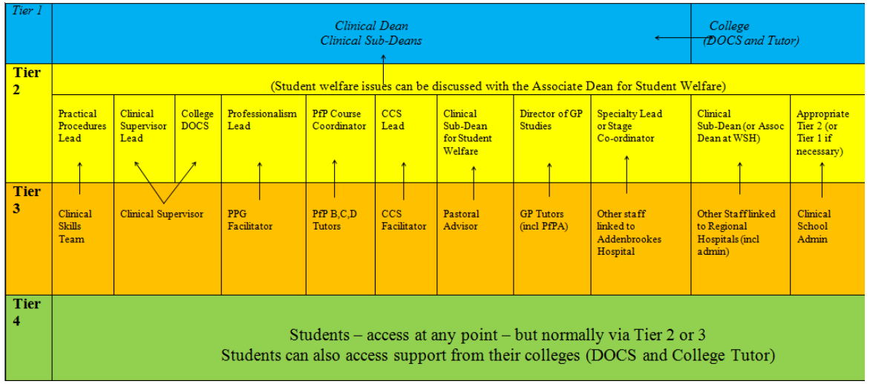

Regional hospital = local whistleblowing policy
- What do they deal with?
  - Any and all concerns with malpractice at that Trust
  - Generally easier and safer to do this via the clinical school
- What does the process involve?
  - Get in touch with the Human Resources department to obtain the local whistleblowing policy, and follow this procedure
  - Policies vary as to whether or not you are able to raise a concern anonymously. You can ask for your identity to be kept confidential, but there are limits to this.
- What are the potential outcomes?
  - Appropriate action (or inaction) taken accordingly
- Contact details
  - [Refer to your local hospital to find HR department]
Taken from https://www.citizensadvice.org.uk/health/nhs-and-social-care-complaints/whistleblowing-how-a-staff-member-can-report-a-problem-in-the-nhs-or-an-adult-social-care-service/

National

NHS whistleblowing
- What do they deal with?
  - Any and all concerns about malpractice, wrongdoing or fraud within the NHS and social care sector.
  - Specifically aimed at employees and managers of NHS and Social Care organisations in England and Wales.
- What does the process involve?
  - You report your concern via phone, email or online form (see below) in a completely confidential and anonymous manner
- What are the potential outcomes?
  - You will receive a response offering legally compliant, unbiased support and guidance to ensure you can act in accordance with your values. This ensures you fully understand your options and legal rights specific to your employment situation.
- Contact details
  - Confidential whistleblowing helpline: 08000 724725
  - Email: enquiries@wbhelpline.org.uk
  - Website: www.wbhelpline.org.uk/

GMC
- What do they deal with?
  - Situations where a doctor poses a risk to patients or a risk to public confidence in doctors i.e. situations where a doctor’s “fitness to practise” is in question. For example:
    - Serious and/or repeated mistakes
    - Fraud or dishonesty
    - Discrimination against patients and/or colleagues
    - Breaching of confidentiality
    - Violence, sexual assault or indecency
- What does the process involve?
  - Raise your concern via the confidential helpline, or the online form (see below)
  - The GMC will get back to you within two weeks after you submit your concern.
  - The GMC will first decide whether or not an investigation would be appropriate from looking at the information provided. If this decision is unclear, they may ask you or the doctor’s employer to obtain more information.
  - If a decision to investigate is made, the doctor in question and their employers are notified. This allows the GMC to find out whether the concern has already been dealt with by the employer or if there is anything else they need to know about.
  - The GMC collects various forms of evidence over the following months to come to a decision in terms of appropriate action.
  - The GMC aims to complete all investigations within 12 months.
  - Interim sanctions (temporary measures) may be put in place during the investigation if it is felt that the doctor’s practice ought to be restricted during this time.
  - The GMC will keep you regularly updated throughout the process unless you request not to be informed.
- What are the potential outcomes?
  - 75% = take no action
  - 5% = issue a warning
  - 8% = doctor to sign undertakings with the GMC, which is an agreement to commit to improve the way they work
  - 11% = refer a doctor to the MPTS (Medical Practitioners Tribunal Service)
    - -> take no action
    - -> issue a warning
    - -> accept undertakings offered by the doctor if agreed with the GMC
    - -> place conditions on the doctor's registration e.g. restricted practice, retraining, or working under supervision
    - -> suspend the doctor's registration
    - -> erase the doctor’s name from the medical register (a.k.a. being “struck off”)
- Contact details
  - Confidential helpline: 0161 923 6399
  - Website: https://www.gmc-uk.org/concerns/raise-a-concern-about-a-doctor#doctor-colleague

Defence organisations (e.g. MDU, MPS) and Protect
- What do they deal with?
  - Providing medicolegal advice and protection for clients. As a medical student, membership to both the MDU and MPS are free of charge.
  - If you are having to write a formal report or statement in raising your concern, it is important to ensure that you do this in a professional and medico-legally safe manner. The MDU explicitly provides guidance on how to do this, and offers to review drafts and associated correspondence with you throughout the process. The MPS may provide a similar service when contacted.
- What does the process involve?
  - Read the relevant webpages or get in touch by phone (see below)
- What are the potential outcomes?
  - Ensure that you protect yourself medico-legally throughout the process of raising your concern
- Contact details
  - MDU medico-legal helpline: 0800 716 646
  - MDU writing a report or statement: https://www.themdu.com/get-mdu-support/i-have-to-write-a-report-or-statement
  - MPS medico-legal advice: 0800 561 9090
Protect is a charity rather than a defence organisation, but is able to fulfil a similar role to the MDU and MPS on this front. It is an independent organisation that focuses solely on whistleblowing, including providing free legal advice and support to employees who are worried about malpractice at work. Their contact details are:
- Tel: 020 3117 2520
- E-mail: whistle@protect-advice.org.uk
- Website: www.pcaw.co.uk

Which avenues are the most appropriate for me?
Avenues available no matter what the situation include:
- College DoS and/or personal tutor
- Clinical school reporting concerns “hierarchy”
- NHS whistleblowing
The following questions will give you an idea of where you could best seek help. For each “Yes” response, there is an additional appropriate avenue that you can or perhaps even ought to follow:
- Did this occur whilst on a hospital placement?
  - -> local whistleblowing policy
- Does this involve a situation that puts a doctor’s “fitness to practise” in question?
  - -> GMC
- Are you having to write a formal report or statement to raise your concern and/or are you concerned about your own medico-legal protection in raising your concern?
  - -> defence organisations (e.g. MDU, MPS), and Protect charity
If any of these situations apply to you, it would be wise (though not obligatory) to speak to your college or the clinical school in the first instance, rather than embarking on these alone.

Personal welfare
While this resource has been primarily designed to aid you in addressing whatever problem you may have encountered, it is also crucial that you obtain your own personal support for any distress you may have experienced.
MedEd has a fantastic page providing a vast array of different sources of support at the clinical school, your college and the university, as well as externally. There is substantial variation in their nature and what they can offer so even if the first does not feel right for you, we would encourage you to try others. We hope that you are able to find something here that is helpful in supporting you.
https://vle.medschl.cam.ac.uk/course/view.php?id=662&section=5

